**Assignment 4: Heap Data Structures: Implementation, Analysis, and Application**

Vishnu Mallam

University of the Cumberlands

Fall - Algorithms and Data Structures (MSCS-532-A01) - First Bi-term

Dr. Vanessa Coope

September 15, 2024

**Introduction**

In the field of computer science, heap data structures are an essential component, particularly for the management of priority queues and the effective sorting of data. The implementation of Heapsort is discussed in this study, along with an analysis of its performance and a comparison of it to certain other sorting algorithms. In addition to this, it investigates the construction of a priority queue by making use of a binary heap and the applications of this implementation in time management.

**Heapsort Implementation and Analysis**

**Implementation**

A method for sorting data that is based on comparison and makes use of a binary heap data structure is called Heapsort. The construction of a max-heap, the extraction of the maximum element, and the preservation of the heap property through the sorting process are the three most important processes in the Heapsort algorithm.

**Heapsort Algorithm Implementation in Python**:

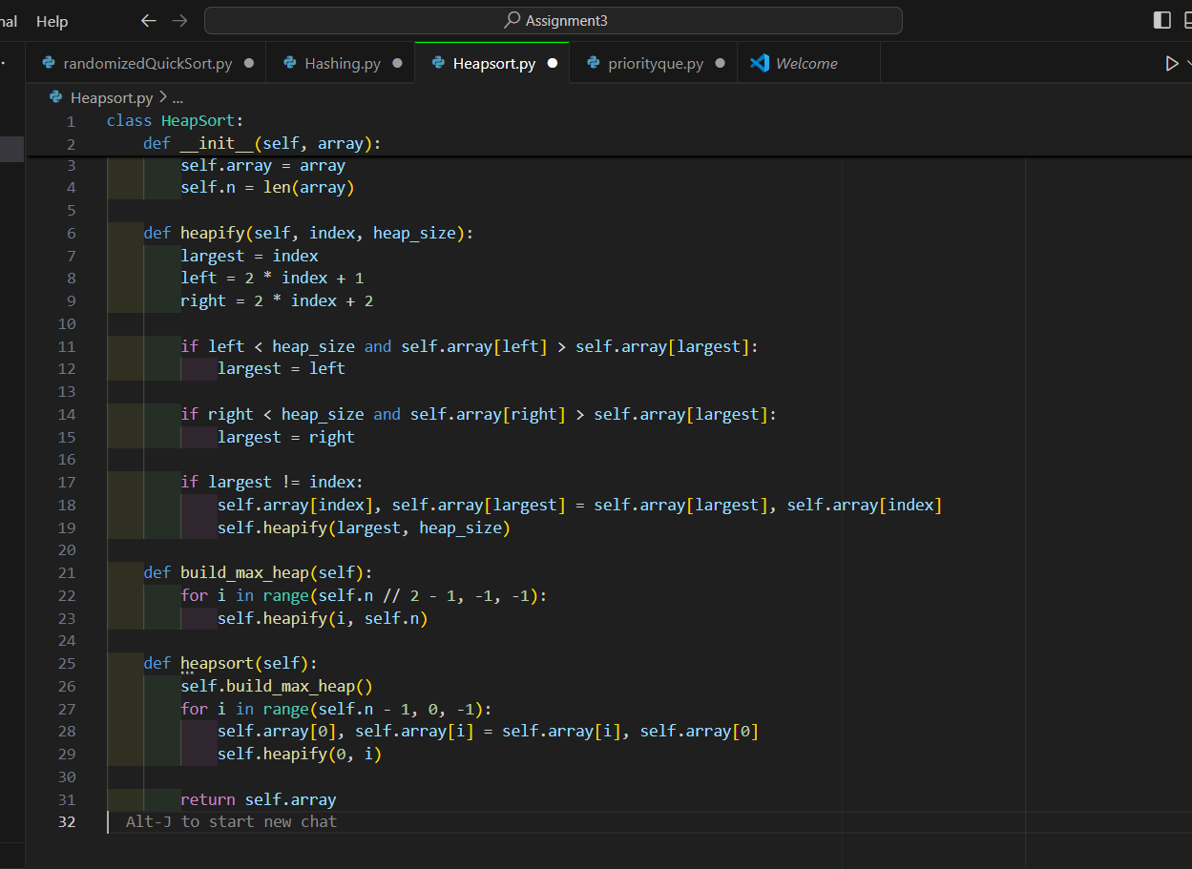Analysis of Implementation

Time Complexity:

* Building the Max-Heap: O(n). Although each heapify operation is O(log n), the overall complexity is O(n) due to the amortized cost of heapify operations across all nodes.
* Heapsort: O(n log n) in all cases. This is because the algorithm performs heapify and extraction operations n times, each taking O(log n) time.
* Best Case: The time complexity remains O(n log n), as even if the array is initially sorted, the algorithm must still build the heap and perform sorting.

Space Complexity:

* The space complexity is O(1) as Heapsort sorts the array in place without requiring additional memory.

**Comparison with Other Sorting Algorithms**

Due to improved cache efficiency and smaller constant factors, Quicksort is often quicker in practice than other classification methods. Nonetheless, in the event that the pivot selection is not satisfactory, it has a worst-case temporal complexity of O(n^2). Despite the fact that it is reliable and consistently O(n log n), the Merge Sort algorithm takes O(n) more space. It is effective when used to huge datasets that have a known amount of temporal complexity.

**Priority Queue Implementation and Applications**

**Data Structure**

A priority queue can be implemented using a binary heap, which is efficiently managed using a list in Python. The Task class encapsulates task details, and the PriorityQueue class provides methods for managing tasks based on priority.

PriorityQueue Class:

**Conclusion**

In this study, a comprehensive implementation of Heapsort and a priority queue was presented, along with an analysis of the time and space complexity associated with each algorithm, and a comparison of Heapsort to alternative sorting algorithms. Furthermore, it elaborated on the fundamental functions of a priority queue and illustrated the practical uses of this queue in the context of task scheduling. It is possible to tackle issues requiring sorting and priority management in an effective manner if one has a solid grasp of these data structures and their performance respectively.

**References**

Anwar, M. R., Apriani, D., & Adianita, I. R. (2021). Hash Algorithm In Verification Of Certificate Data Integrity And Security. Aptisi Transactions on Technopreneurship (ATT), 3(2), 181-188.

Cormen, T. H., Leiserson, C. E., Rivest, R. L., & Stein, C. (2022). Introduction to algorithms. MIT press**.**